**Contribution Declaration Form**

**(to be completed by all team members)**

**Please fill in the form with the contribution from each student towards the assignment.**

**1 NAME AND CONTRIBUTION DETAILS**

|  |  |  |
| --- | --- | --- |
| Student ID | Student Name | Contribution Percentage |
| 28855205 | Hamidreza MohammadianDehkordi | 50 |
| 29003164 | Sunil Cyriac | 50 |
|  |  |  |
|  |  |  |

**2 DECLARATION**

**We declare that:**

* The information we have supplied in or with this form is complete and correct.
* We understand that the information we have provided in this form will be used for individual assessment of the assignment.

**3 SIGNATURE**

**Signatures**

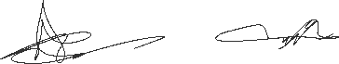

DayMonth Year

16 / 04 /2018 20182018

**Date**